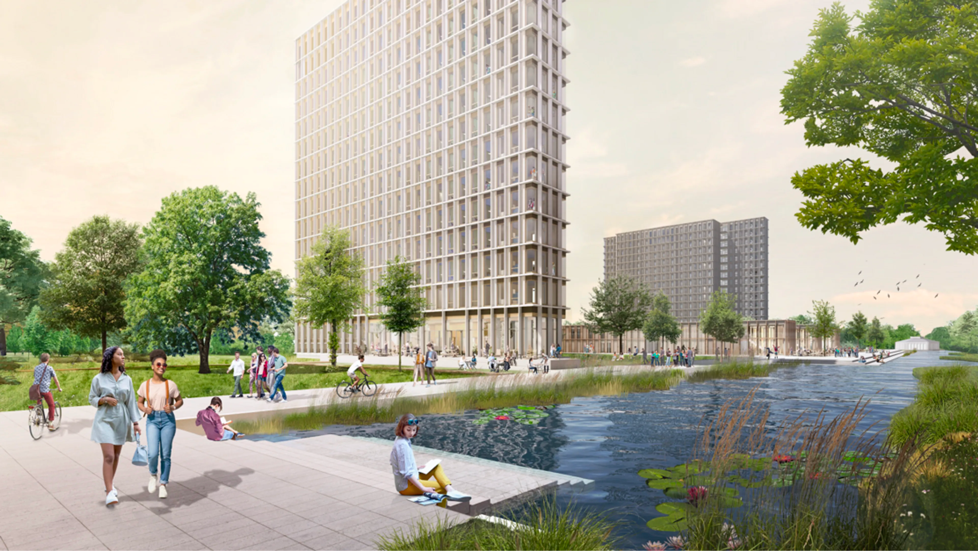

Woonbedrijf

International Week Group Project

Group: 1

Date: 09/05/2023

Team: Tudor, Anastasia, Paulina, Jenny, Fabio, Kun, Erick, Huber, Harun, Emilija

# Introduction

In this international project, we were tasked by Woonbedrijf to design an interactive tool for Vestide, a part of Woonbedrijf that stimulates students to share their ideas about what the core values mean for them if they would be a part of the LOT community (Vestide’s community). There are 4 core values of the LOT community, including giving power to the people, arms wide open, exchange, and on and offline blend.

# 

# Table of content

**Table of content 3**

**Assignment 4**

Context 4

Problem definition 4

Assignment 4

Goal 4

Scope 4

Research question 5

**Planning and Approach 6**

Methodology 6

Research tools 6

Define 7

Ideate 8

Prototype 9

**Deliverables 10**

# Assignment

## Context

By July 2024, Vestide intends to develop a fresh student apartment complex on the TU/E campus. Despite unfinished construction, Vestide aims to create a community for students named LOT. Various issues associated with the new student housing have already been addressed by students, and Vestide is eager to motivate and stimulate them to participate in the decision-making process for further development of the plans. To facilitate this, Vestide has initiated its student community, LOT.

## Problem definition

Vestide aims to establish a student community at the TU/E campus where active participation in decision-making is encouraged. The students have already raised multiple concerns and suggestions, but Vestide aspires to further motivate and stimulate their engagement in shaping the campus's development.

## Assignment

Design an interactive tool which stimulates students to share their ideas of what the core values mean for them if they would be part of the LOT community. The tool should be visible at the TUE campus (outside) and input should be presented in a way that inspires others. For example, think of an exposition which represents the core values.

## Goal

The goal of this assignment is to create an interactive media or platform where students at the TU/E campus are able to participate and share their ideas on the core values with the help of artificial intelligence to realise their feedback while achieving sustainable development goals.

## Scope

Includes:

Innovative technologies

SDG (sustainable development goals)

Core values

HiFi designs

Not included:

User testing

## Research question

“In what way can new technologies contribute to reaching Sustainable Development Goals (SDG’s)?“

The following sub-questions are derived from the above question in combination with the assignment:

* How can we motivate students to share their ideas?
* How can we utilise AI to visualise their ideas?
* Where and how are we presenting these ideas?

## 

# Planning and Approach

## Methodology

We will be working on the project according to the *design thinking method*, which is a non-linear, iterative process that teams use to understand users, challenge assumptions, redefine problems and create innovative solutions to prototype and test. There are 5 phases involved: Empathise, Define, Ideate, Prototype, and Testing.

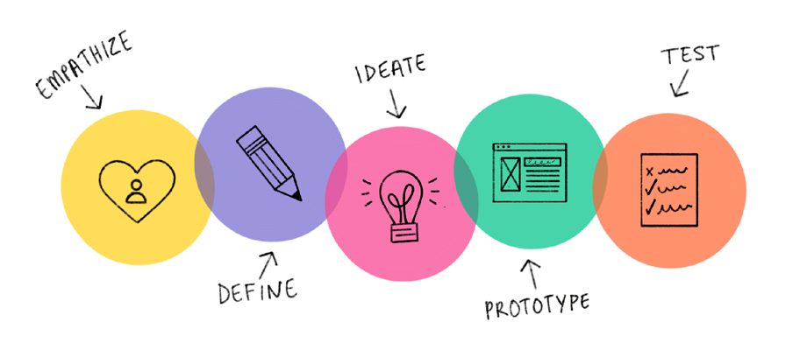

## Research tools

We will be using the CMD methods pack to conduct this project. because this project is only going to be held for one school week, we won’t have the time to conduct user testing.

For the empathise phase, we will be conducting **interviews**, and research into new technologies, specifically **AI image generators**.

For the define phase, we will be using **user stories** and **personas**.

For the ideate phase, we will create **wireframes** to display the basic layout of our design.

For the prototype phase, we will create high-fidelity, interactive **prototypes**.

### Empathise

**Interviews**

To get to know the target audience, we conducted interviews with students who would benefit from our design. The interviewees will be randomly selected and remain anonymous.

**AI Research**

As promised in the sub questions, we will be researching AI image generators and compare to each other; to see which one is most suitable for us.

### Define

**User Stories**

User stories are used to capture a description of a software feature from a user's perspective. This way, we can know the features and functionalities that will be realised in the final design.

**Persona**

Personas are fictional characters which we came up with based on our understanding from Vestide’s target audience. This is to represent the different user types (students) that might use our design. Creating personas helps us to understand their needs, goals, etc. In this project

### Ideate

**Wireframe**

Wireframing is a way to realise our designs at the structural level. It is commonly used to layout content and functionality on a page which takes into account user needs and user journeys.

### Prototype

**Prototyping**

Prototyping is an experimental process where we implement the wireframes we designed to a high fidelity and interactive design that represents our final design. Prototyping serves to provide specifications for a real, working system rather than a theoretical one.

Additionally, we will include **screenshot(s) of the environment** that we visioned and rendered. This will help us demonstrate and visualise how we will implement our design in the real world.

# 

# Deliverables

At the end of the project, the following deliverables will be provided:

1. Interactive prototype that meets the project requirements.
2. Visual demo of the end result that showcases project's features.
3. Video presentation
4. A project report that summarises the project objectives, requirements, implementation and results.